**Node JS Architecture**

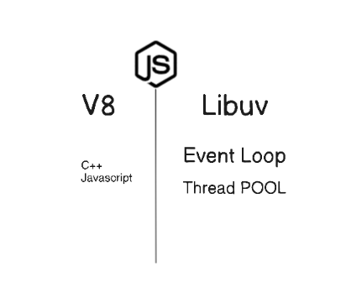

Node JS is combination of V8 Engine and LibUV. Due to this Libuv, node js can handle Event loop and work as multi thread application.

**Internal Working of Node.js script**

When we execute node index.js script.

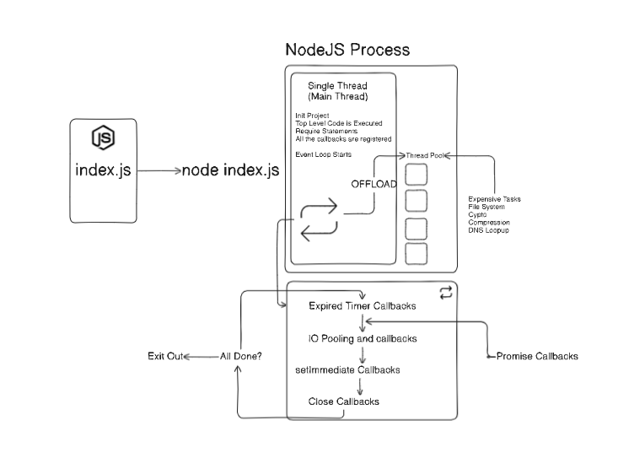

When we execute the node index.js script.

1. A node Js process gets creates, which will have Single/Main Thread and Thread pool, Event loop
2. Inside the Main Thread, below are the steps it executes.

* Initialise the project
* Top Level code is executed. (eg. const app = express() etc)
* All the require statements get executed.
* All the callbacks gets registered.

3.Event Loop starts.

* If any blocking calls are there such as (Expensive task, crypto, file system, DNS lookup etc)
* If there are no any blocking calls then below are the steps Event loop executes to

1. Checks if any Expired callbacks are there for execution.
2. Checks for IO pooling callbacks
3. setImmediate callbacks
4. Close callbacks

If all the above completed then exit out else it loop over untill all the steps are over.